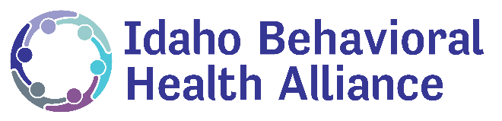
What is Behavioral Health?
Behavioral health conditions refer to mental illnesses, substance use disorders, or when an individual experiences both mental illness and substance use disorder – or “co-occurring” conditions.
Frequently Asked Questions about Mental Health
- What is mental illness?

Mental illness refers to many conditions that impact a person’s thinking, emotion and/or behavior. There are over 200 different forms of mental illness, including depression, schizophrenia, bi-polar, and anxiety disorders. Mental illness, like other health conditions, is treatable and recovery is possible.

- How many Idahoans have a mental illness?

One in four Idahoans experience some form of mental illness, and 13% of Idaho children 12-17 years old have had a major depressive episode in the last year. Mental illness can affect anyone, and if you do not have mental illness, it is likely you know and care about many people who live with mental illness.

- What causes mental illness?

Many factors may play a role in someone developing a mental illness. Genetics, trauma, stress, and even physical conditions (like injury or diabetes) can affect mental health.

- Do people recover from mental illness?
Yes! Advancements in research and a variety of treatments mean that recovery is possible. With access to medication, services, and supports, people with mental illness can effectively manage their condition and live healthy lives. However, these aren’t the only ways individuals can engage in and succeed in recovery.
Here are a just a few conditions and their recovery rates:
- Bipolar Disorder - 80%
- Major Depression - 70%
- Panic Disorder - 70%
- Obsessive-Compulsive Disorder - 70%
- Schizophrenia - 60%

The Substance Abuse and Mental Health Services Administration Behavioral Health Barometer: Idaho, Volume 4
The Substance Abuse and Mental Health Services Administration defines recovery as “A process of change through which individuals improve their health and wellness, live a self-directed life, and strive to reach their full potential.”
National Alliance on Mental Illness

