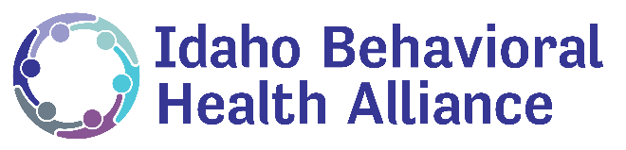
Impact of Medicaid Expansion for Idahoans with Behavioral Health Conditions
Behavioral Health in Idaho
Behavioral health conditions impact a substantial number of Idaho families and are especially common among people with low incomes. Behavioral health conditions include mental illnesses, such as anxiety disorders, major depression, bipolar disorder, schizophrenia, and post-traumatic stress disorder, as well as substance use disorders, such as opioid addiction. It is estimated that 1 in 4 Idahoans live with a mental illness, and 1 in 20 have a substance use disorder. For those without insurance and access to health care, managing a life with behavioral health conditions can be exceedingly difficult.
Medicaid expansion in Idaho means that these people will have access to specialized behavioral health services. Individuals with behavioral health conditions have a unique and difficult set of needs, and Medicaid plays a large role in easing access to necessary treatment.
Medicaid Finances Complex Behavioral Health Treatment
Additionally, Medicaid is sometimes more comprehensive than private insurance in coverage of behavioral health services, which can require a wide array of complex medical and long-term care services. Some of these services include outpatient and inpatient treatment such as individual and group therapy, case management, hospital visits, and residential treatment. It also covers medications as part of psychiatric treatment for mental illness or medication-assisted treatment for substance use disorders, as well as home and community-based services, like supportive housing and supported employment.
Medicaid Helps Idaho Children
Because Medicaid has the Early, Periodic Screening, Diagnosis, and Treatment benefit for children, behavioral health services for children are particularly comprehensive. EPSDT includes all medically necessary Medicaid services permitted under federal law and is required for children from birth to age 21. Under this benefit, states must provide access to behavioral health care, including screenings and assessments. Children diagnosed with behavioral health conditions receive any service available under federal Medicaid law necessary to treat the condition, even if the state does not cover that same service for adults.
Medicaid Creates Access People Use
Medicaid offers adults access to treatment that they normally wouldn’t be able to afford. In 2015, those adults with behavioral health conditions and Medicaid were twice as likely as those without coverage to receive mental health treatment and substance use disorder treatment.
Medicaid Saves Idaho Millions
Currently Idaho spends tens of millions of dollars a year to treat people with behavioral health conditions. These expenses are paid through the Idaho Department of Correction and Idaho Department of Health and Welfare’s Division of Behavioral Health. Medicaid expansion would mean that 93% of the people that the Department of Health and Welfare serves would become Medicaid-eligible. The most recent Milliman report shows that over a ten-year period, the state would save about $185 million just in behavioral health services alone.
More than that, Medicaid expansion means people will be able to get access to preventive care and treatment, allowing them to participate more fully in life. The true impact of people living healthy lives and contributing to our Idaho way of life and economy may be much greater.

